**Tableau Dashboard Documentation**

**Date:** 03 June 2025

1. **Progress Report Card**

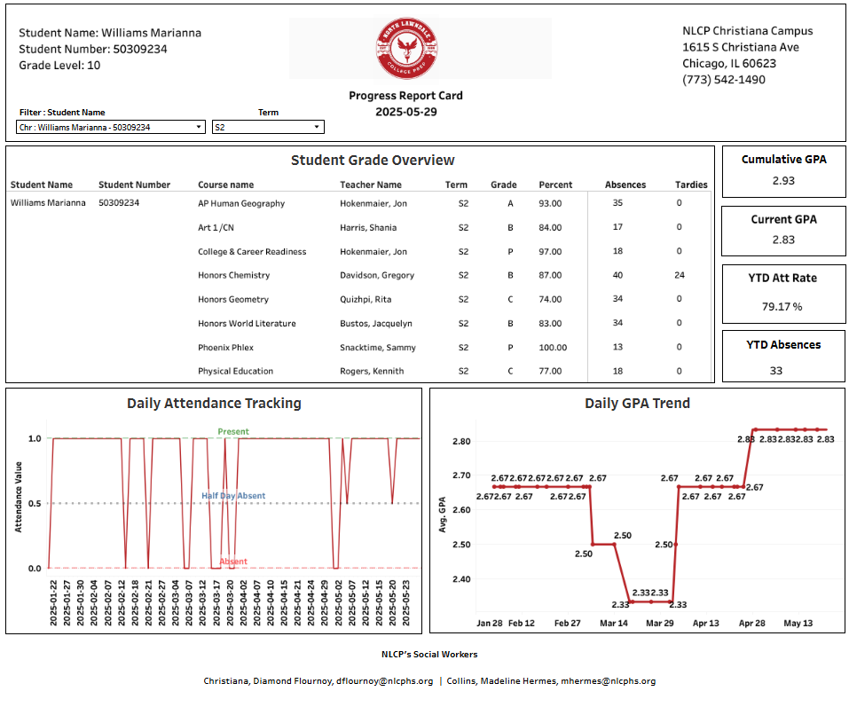

### **What the Dashboard Shows**

* Student Info & Filters: Displays student name, ID, grade level, and term selection.
* Student Grade Overview (Table): Lists all courses with corresponding teachers, grades, percentages, absences, and tardies for the selected term.
* Cumulative & Current GPA Panel: Shows both the student’s overall (cumulative) GPA and GPA for the current term. Also includes year-to-date attendance rate and total absences.
* Daily Attendance Tracking (Chart - Left): A line chart showing whether the student was present (1), half-day absent (0.5), or absent (0) on each day over time.

Daily GPA Trend (Chart - Right): Line graph tracking the student’s GPA changes over time, helping visualize performance improvements or drops.

1. **Network Dashboard**

### **What Each Chart Shows**

* Attendance Rate Chart: Line chart showing daily attendance trends over time for each campus.
* Log Categories per Student: Bar chart showing the number of behavior logs per category (Discipline, Documentation, Peace) by campus and grade.
* Daily Average Current GPA: Line chart showing how GPA has changed daily over time by campus.
* Current GPA: Bar chart showing the current GPA of individual students by grade and campus.
* Daily On Track: Bar chart showing the percentage of students considered “on track” daily by grade and campus.
* Count of YTD Absences: Bar chart showing the number of year-to-date absences per student by campus and grade.
* KPI Tiles (Bottom Row):
  + Attendance Rate: Average attendance percentage per campus.
  + Enrollment: Number of enrolled students by grade and campus.
  + Average of Current GPA: Average GPA per grade and campus.
  + Average Attendance Rate: Grade-level attendance average by campus.
  + Daily On Track %: Daily “on track” percentage by grade and campus.
  + 9–12 PACT (GPA ≥ 3.0): Percent of students with GPA ≥ 3.0 by grade and campus.

1. **Pass-Fail Statistics Dashboard**

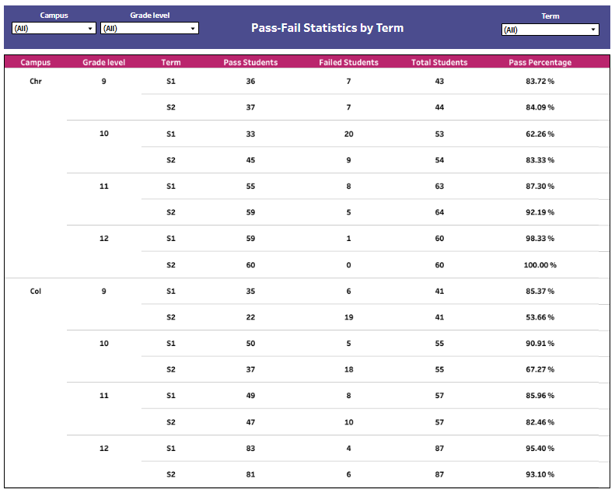

This dashboard provides a term-wise summary of student pass and fail rates across campuses and grade levels. It helps identify academic performance patterns and areas that need intervention.

### **What the Table Shows**

* Campus: Indicates the campus (Chr or Col).
* Grade Level: Student grade (9–12).
* Term: Academic term (S1 or S2).
* Pass Students: Number of students who passed in that term.
* Failed Students: Number of students who failed.
* Total Students: Total number of students considered.
* Pass Percentage: The percentage of students who passed (calculated from total).

1. **Current Grades Dashboard**

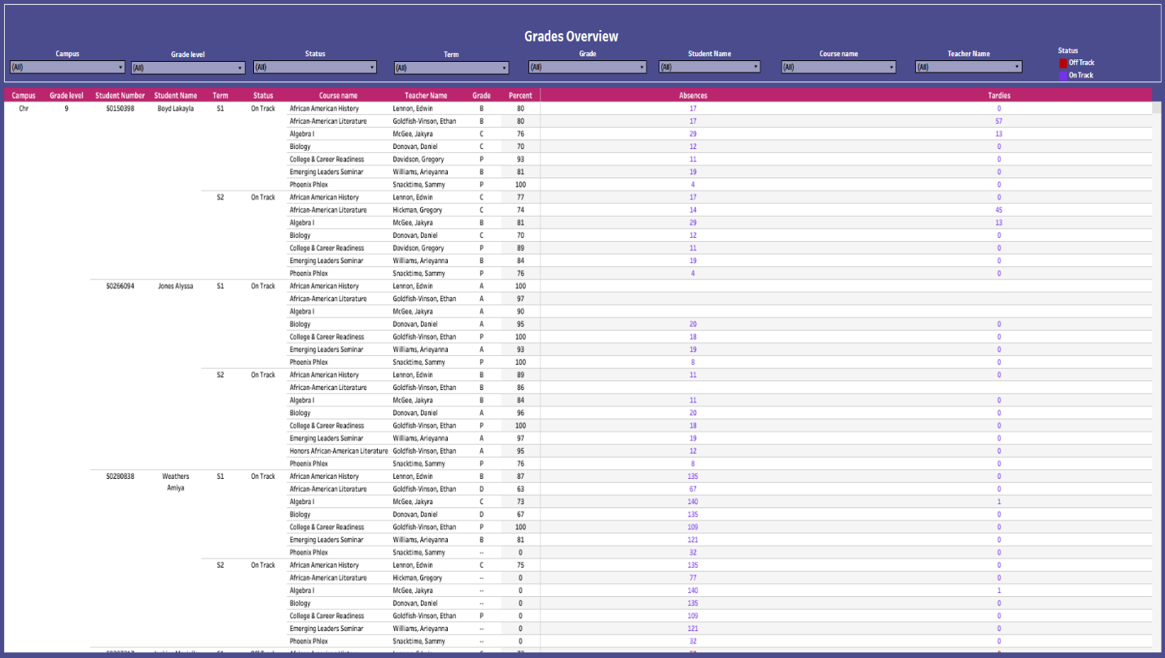

This Grades Overview dashboard provides a comprehensive look at student academic performance, attendance, and engagement across selected campuses and grade levels. It helps educators and administrators track student progress, identify those who are "On Track" or "Off Track," and monitor absences and tardies on a per-course basis.

### **Main Table: Grades Overview**

* Campus, Grade Level, Student Number, Student Name: Identify individual students and their context.
* Term: Indicates the semester (S1 or S2) for the listed courses.
* Status: Shows whether the student is "On Track" (blue) or "Off Track" (red).
* Course Name & Teacher Name: Lists the subjects each student is enrolled in along with the respective instructors.
* Grade & Percent: Displays letter grades (A–F) and percentage scores for each course.
* Absences: Total number of absences per course.
* Tardies: Number of tardies recorded for each course.

1. **Logs Report**

This **Logs Report** dashboard provides a detailed record of behavioral and administrative logs for students across different schools and grade levels. It helps staff track student behavior incidents, documentation, peace circles, and interventions over a selected time range.

### **Log Report Table**

This central table lists individual log entries by student, allowing detailed tracking and filtering of incident types, subtypes, and related actions.

* **School Name, Grade Level, Term**: Identifies the context in which the incident occurred.
* **Entry Date & Student Name**: Specifies when the log was recorded and which student it involved.
* **Log Type Name**: Categorizes logs as Documentation, Peace, Discipline, etc.
* **Incident Type & Subtype**: Details the nature of the behavior or administrative action (e.g., Dean’s Log, Learning 2 Rise, Parent Contact).
* **Full Description/Notes**: Provides a narrative or explanation of the event or behavior.
* **Consequence & Consequence Served**: Indicates any disciplinary action assigned and whether it was carried out.
* **Admin Action & Teacher Action**: Lists follow-up steps taken by administrators or teachers in response to the log.

1. **Consequence Count Dashboard**

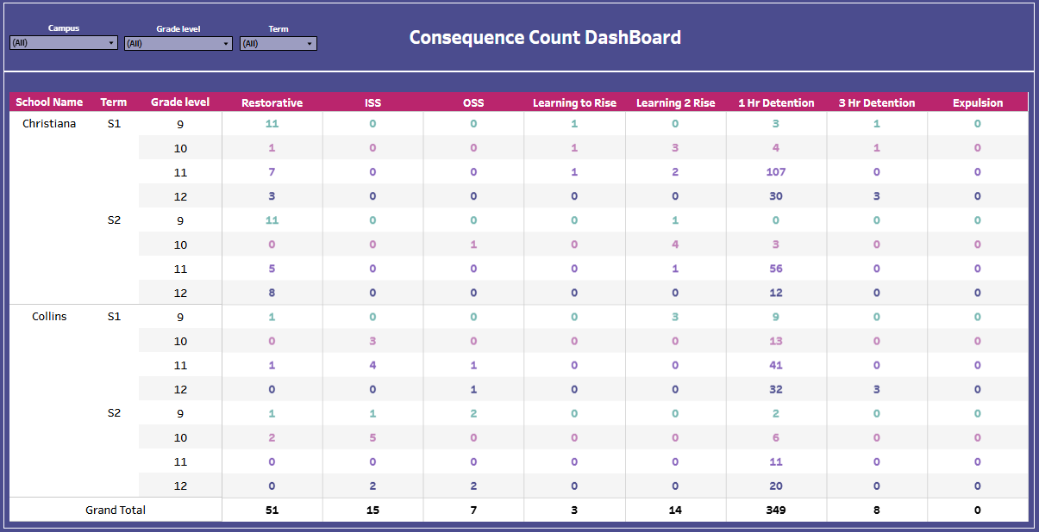

### **Dashboard Overview**

The **Consequence Count Dashboard** provides a summary of disciplinary actions assigned to students across different schools, terms, and grade levels. It helps track the frequency and distribution of various consequences to monitor behavioral interventions.

### **Consequence Metrics Table**

* **School Name, Term, Grade Level**: Shows the school campus, term (S1/S2), and grade (9–12) for context.
* **Restorative**: Count of restorative interventions assigned, such as peer mediation or reflective activities.
* **ISS (In-School Suspension)**: Number of students assigned in-school suspension.
* **OSS (Out-of-School Suspension)**: Number of students removed from campus as disciplinary action.
* **Learning to Rise & Learning 2 Rise**: Specialized programs focused on behavioral growth; each column tracks respective participation counts.
* **1 Hr Detention & 3 Hr Detention**: Number of short (1-hour) and extended (3-hour) detentions assigned.
* **Expulsion**: Count of students who received expulsion as a disciplinary action.

1. **Discipline – Incident Type Dashboard**

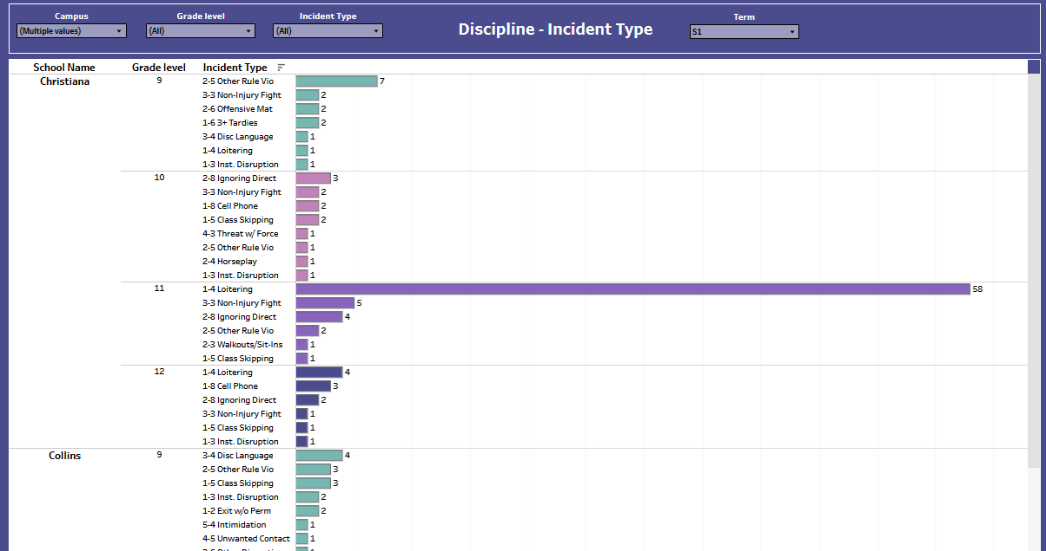

### **Dashboard Overview**

The **Discipline – Incident Type Dashboard** presents the distribution of various behavioral incidents reported across campuses, categorized by grade level and incident type. This helps identify trends in student behavior and target interventions accordingly.

### **Incident Metrics Breakdown**

* **School Name & Grade Level**: Indicates where and for which grade each incident was recorded.
* **Incident Type**: Shows specific behavior categories such as "Non-Injury Fight", "Disruption", "Loitering", "Cell Phone", etc., each labeled with a code (e.g., 2-5, 1-3).
* **Bar Graph**: Visualizes the frequency of each incident type per grade—longer bars indicate higher occurrence.
* **Highest Frequency**: Christiana Grade 11 reports the most incidents, with **58 cases of 1-3 Inst. Disruption**.

1. **The Sieve Dashboard**

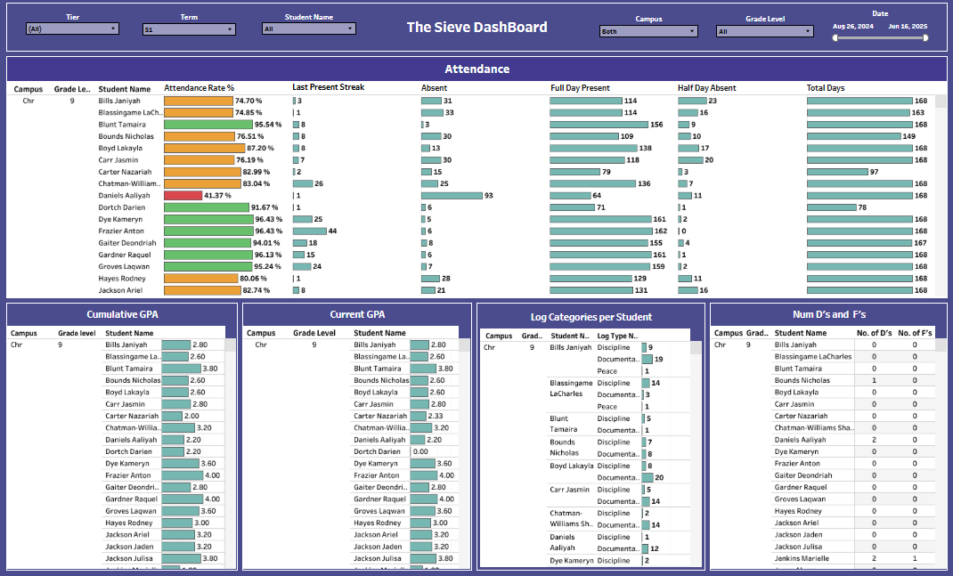

### **Overall Summary**

This dashboard gives an overview of **student attendance, academic performance, behavior logs**, and **academic risk indicators** for **9th grade students** at **Christiana campus** during **Term S1**.

### **Chart Breakdown**

* **Attendance Rate %**  
   Shows how consistently each student attends school. Most are above 75%, but one student is critically low at 41%.
* **Last Present Streak**  
   Displays how many consecutive days a student has been present. Longer streaks reflect consistency.
* **Absent**  
   Total number of days each student was absent. Most have low absences, but one student stands out with very high absence.
* **Full Day Present / Half Day Absent**  
   Visualizes how many full or half days students attended or missed. Useful for spotting partial attendance issues.
* **Total Days**  
   Confirms the total number of school days (mostly 168), acting as a reference point.
* **Cumulative GPA**  
   Long-term academic average. Most students fall between 2.0–4.0.
* **Current GPA**  
   Reflects academic performance this term. Similar to cumulative but highlights recent trends.
* **Log Categories per Student**  
   Shows types and frequency of behavioral or documentation logs (e.g., discipline, peace, documentation).
* **Number of D’s and F’s**  
   Highlights students struggling academically. Most have none, but a few show multiple failing grades.

1. **Advisory Attendance Report**

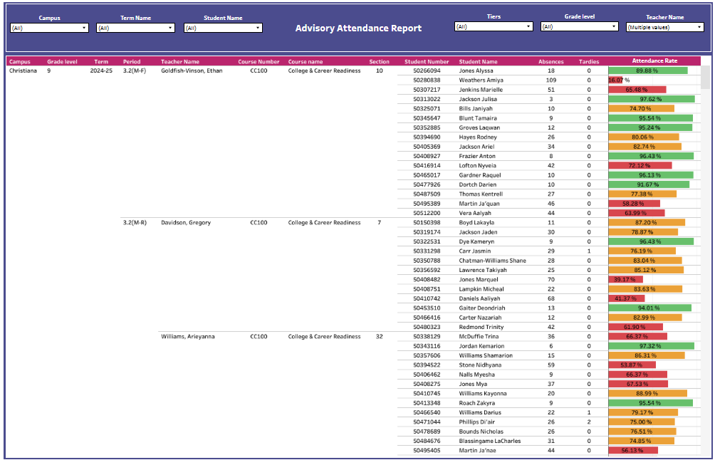

### **Overall Summary**

The **Advisory Attendance Report** shows 9th-grade student attendance for multiple advisory teachers at Christiana campus. It includes **absences, tardies, and attendance rates**.

### **Chart Info**

* **Teacher Columns**: Shows each advisory teacher and their students.
* **Absences & Tardies**: Tracks how often students miss or are late.
* **Attendance Rate**: Bar chart with color coding (green = good, red = poor).
* **Main Insight**: Wide variation in student attendance across different teachers.

1. **Top Advisory Attendance Insights**

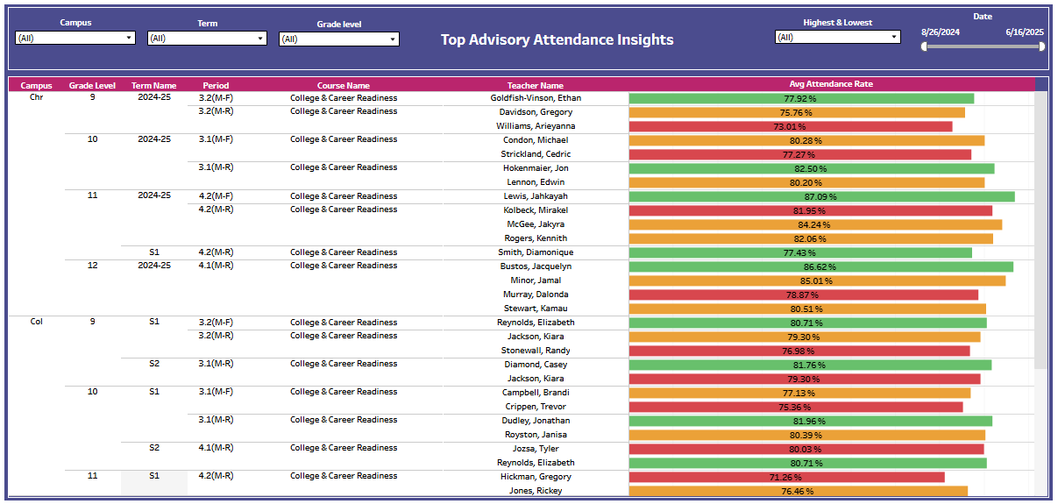

### **Overall Summary**

This chart compares **average advisory attendance rates** by teacher across campuses, grade levels, and terms. It helps identify which teachers have higher or lower student attendance.

### **Chart Info**

* **Teacher Name**: Listed with course and period.
* **Avg Attendance Rate**: Color bars show percentage (green = high, red = low).
* **Campuses**: Includes both Christiana (Chr) and Collins (Col).
* **Main Insight**: Attendance varies significantly between teachers—even in the same grade or course.

1. **Daily Absence Records**

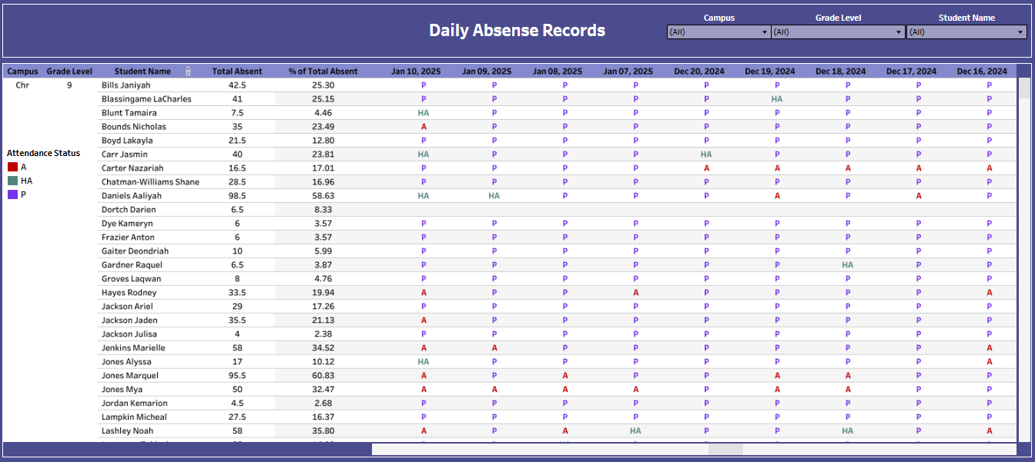

### **Overall Summary**

This chart tracks individual student attendance by day, showing patterns in presence (P), absence (A), and half-day absence (HA). It also includes total absences and percentage of total absences.

### **Chart Info**

* **Student Name**: Listed by grade and campus.
* **Total Absent**: Number of days each student missed.
* **% of Total Absent**: Shows how much of the school year was missed.
* **Daily Record Columns**: Attendance marked per day (color-coded):
  + **P** (Purple) = Present
  + **A** (Red) = Absent
  + **HA** (Green) = Half-day Absent

1. **Tardies Dashboard**

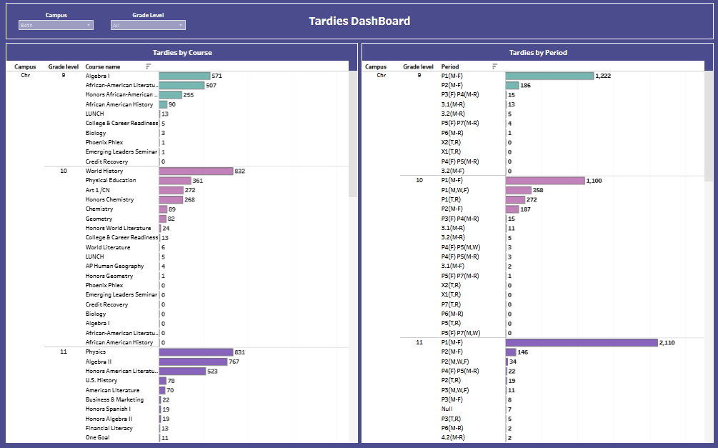

### **Overall Summary**

This dashboard tracks **student tardies** broken down by **course** (left chart) and **class period** (right chart), across grades 9 to 11 at the "Chr" campus.

### **Chart Info**

* **Tardies by Course (Left Chart)**

This chart shows **how many tardies happened in each course**, grouped by **grade level**.  
 It helps identify which classes students are arriving late to the most — for example, World History and Physics have very high tardy counts, meaning many students are not getting to those specific classes on time.

* **Tardies by Period (Right Chart)**

This chart breaks down **tardies by class periods**, again grouped by **grade level**.  
 It shows which **time of day** students are most often late — especially noticeable in 1st period (P1), where tardies are extremely high across all grades, suggesting a widespread issue with students being late at the start of the day.

1. **IEP Comparison Dashboard**

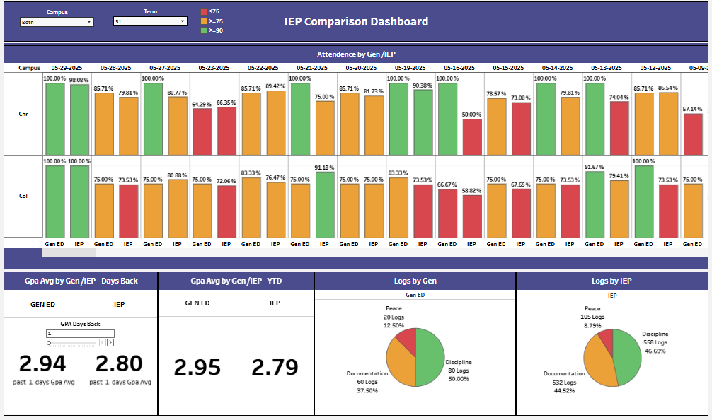

### **Overall Summary**

This dashboard compares performance and behavior between General Education (Gen Ed) and IEP students.

### **Chart Info**

**1. Attendance by Gen/IEP:**  
 Displays daily attendance percentages for both student groups using color codes to indicate attendance levels.

**2. GPA Avg by Gen/IEP – Days Back:**  
 Shows recent GPA averages for Gen Ed and IEP students over a selected number of past days.

**3. GPA Avg by Gen/IEP – YTD:**  
 Compares the year-to-date GPA average between Gen Ed and IEP students.

**4. Logs by Gen:**  
 Presents a breakdown of log types (e.g., discipline, documentation, peace) recorded for Gen Ed students.

**5. Logs by IEP:**  
 Displays the distribution of behavior and support logs for IEP students.

1. **MTSS Dashboard**

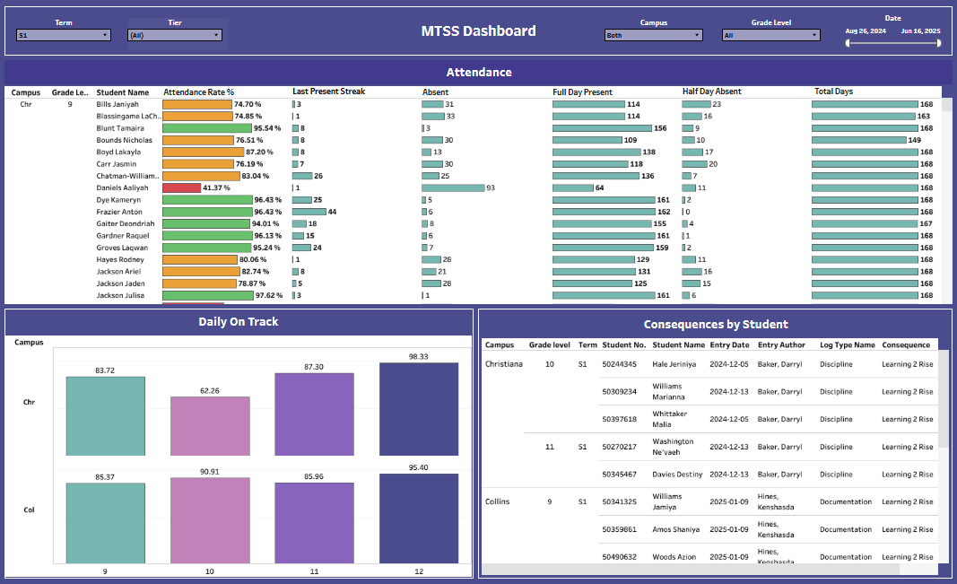

### **Overall Summary**

This dashboard tracks student attendance trends, daily progress, and behavioral consequences to support MTSS (Multi-Tiered System of Supports) interventions.

### **Chart Info**

**1. Attendance (Top Section):**  
 Displays each student’s attendance rate, current present streak, total absences, and presence breakdown (full-day and half-day).

**2. Daily On Track (Bottom Left):**  
 Shows the percentage of students on track daily by campus and grade level.

**3. Consequences by Student (Bottom Right):**  
 Lists students who received behavioral or documentation logs, including log type, date, and assigned consequences.

1. **Peace Warrior Dashboard**

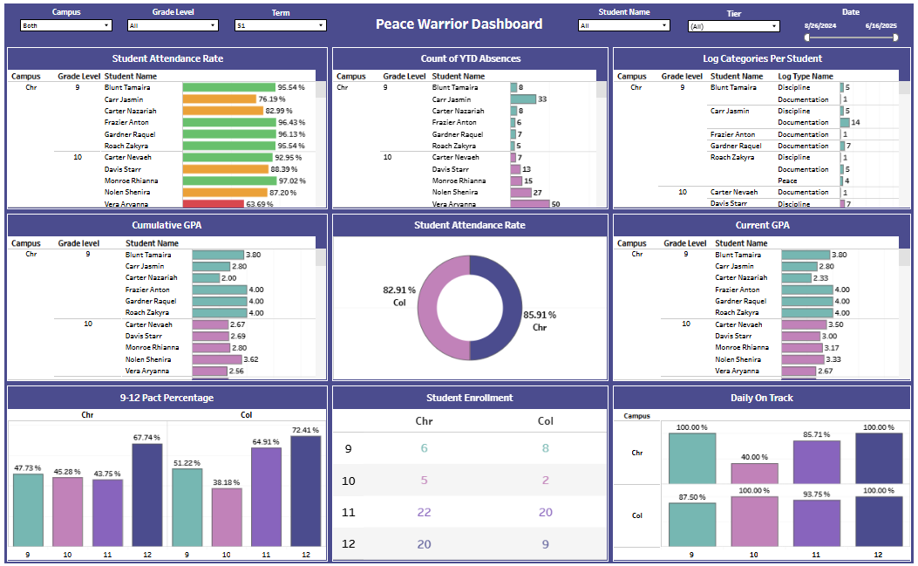

### **Overall Summary**

This dashboard monitors key student success indicators, including attendance, behavior, GPA, and engagement, to support student progress and intervention planning.

### **Chart Info**

**1. Student Attendance Rate (Top Left):**  
 Shows individual student attendance percentages.

**2. Count of YTD Absences (Top Center):**  
 Displays total year-to-date absences for each student.

**3. Log Categories Per Student (Top Right):**  
 Breaks down behavior or documentation logs per student by type.

**4. Cumulative GPA (Middle Left):**  
 Lists each student's cumulative GPA for long-term performance tracking.

**5. Student Attendance Rate (Donut - Middle Center):**  
 Compares average attendance rate by campus.

**6. Current GPA (Middle Right):**  
 Shows students' GPA for the current term only.

**7. 9-12 Pact Percentage (Bottom Left):**  
 Displays percentages of students meeting post-secondary pact goals by grade and campus.

**8. Student Enrollment (Bottom Center):**  
 Counts students by grade level and campus.

**9. Daily On Track (Bottom Right):**  
 Shows the percentage of students on track daily by grade and campus.